Extension of Time and Loss & Expense Narrative #: Site Accommodation/ Health Centre

A. Introduction
- This narrative sets out the Contractor’s (ULS) entitlement arising out of delays and changes to the area for site accommodation provided by the Employer (THDM) and the instruction to accelerate the Health Centre.
- The change to the area for the site accommodation and the instruction to accelerate the Health Centre was a Change under clauses 5.1.2.1, 5.1.2.2 and/or 5.1.2.4 of the Contract and constituted a Relevant Event under clauses 2.26.1 and/or 2.26.6 and a Relevant Matter under clauses 4.21.1 and/or 4.21.5 respectively.

B. Summary
- In the Contract, two areas were proposed for the site accommodation. Option 1 was off-site. Option 2 was the area of Block C (the Health Centre). The off-site area was made available late by THDM. However, it also instructed ULS to accelerate the Health Centre, in advance of the Date for Completion, meaning the area of Block C also could not be used for the site accommodation.
- The delay/change to the availability of the planned areas for the site accommodation caused delays to and required the re-sequencing and re-programming of ULS’s Works.

C. Position under the Contract
- Under the Contract, THDM was to provide ULS with an area for site set-up/ site accommodation (i.e. ).
- In the Employer’s Requirements, there were two options for the site set-up/ accommodation area. These options were shown on the TTMO (Temporary Traffic Management Order) drawing rev 1 dated 12 March 2020 (TTMO Plan) included in the Employer’s Requirements at item/sub-folder 58 of the Schedule of Employer’s Accepted Items (SEAIs):
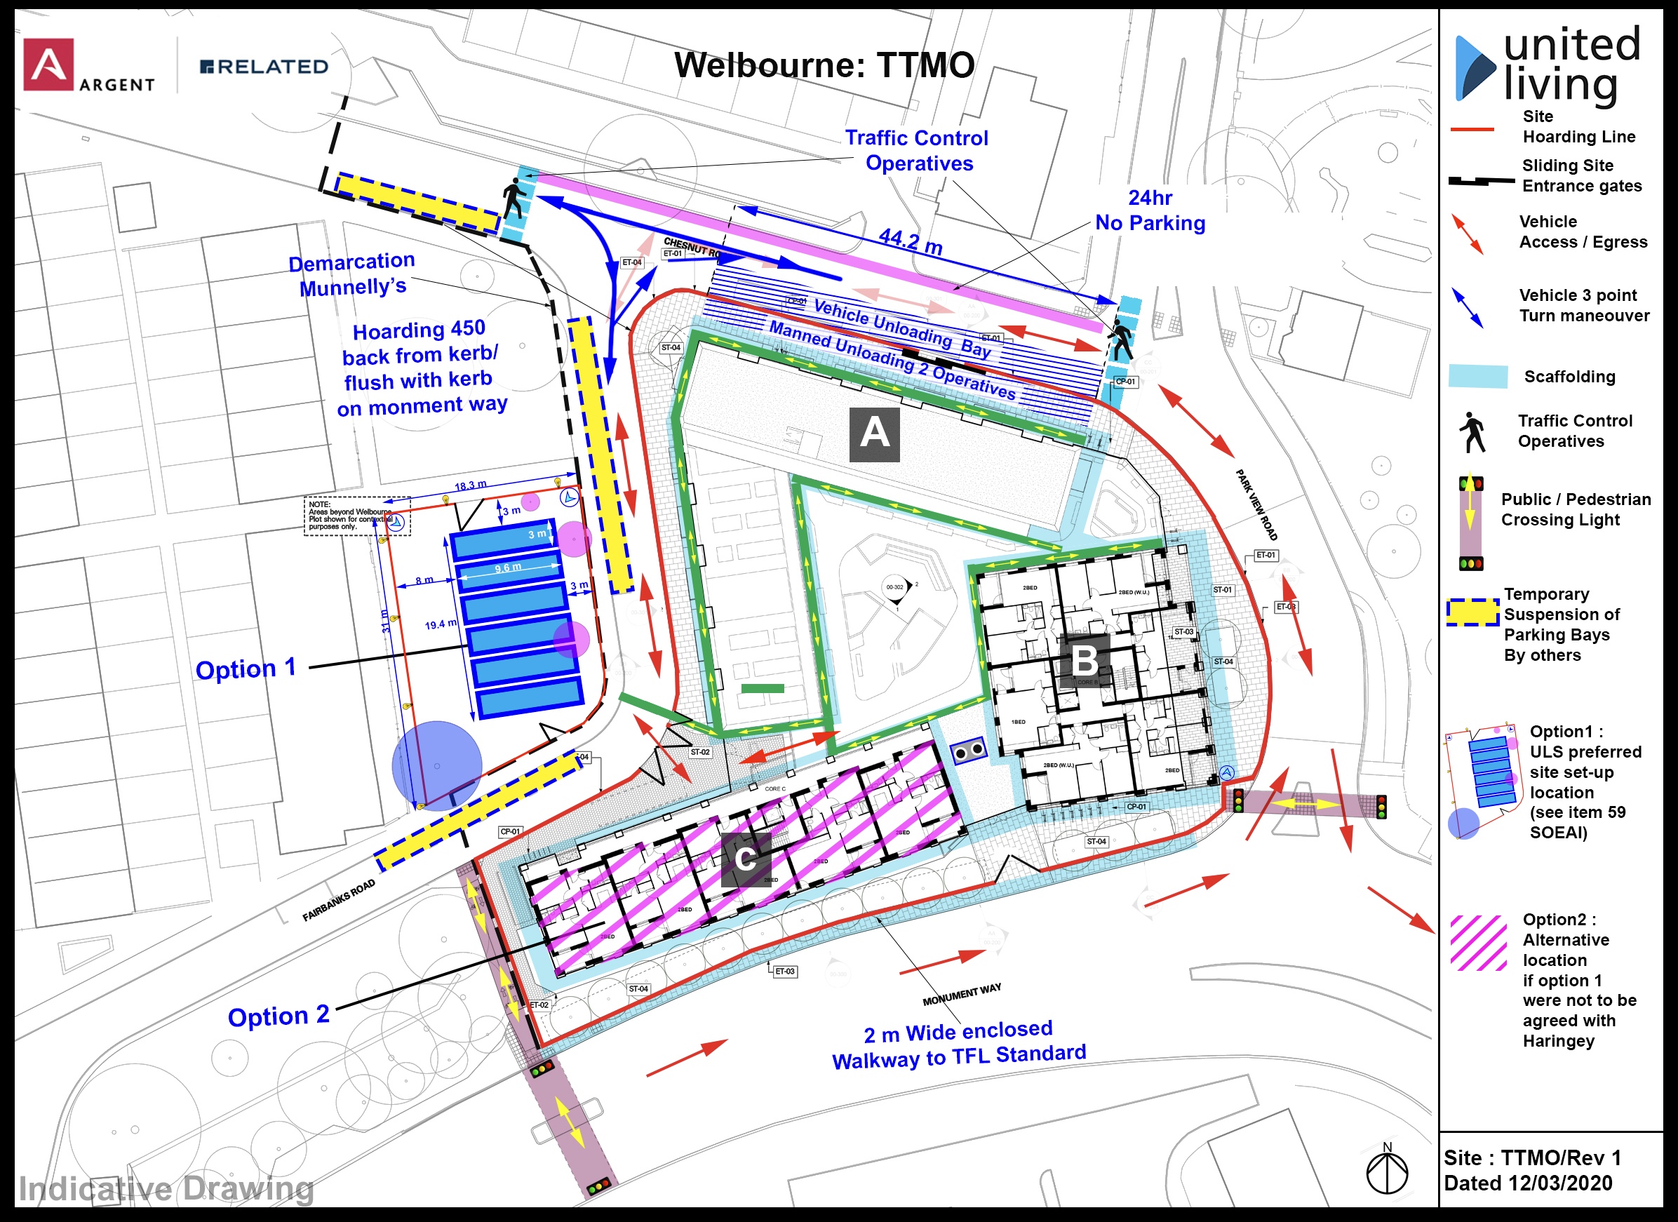
- Option 1 was off-site, on an adjacent plot to the west of the site, the other side of Fairbanks Road. Option 1 required agreement by Haringey Council.
- Option 2 was to use the area on which Block C (the largest low-rise block) was to be built to the south of the site. Block C was to have a health care centre on the ground and first floors, with residential accommodation on floors above.
- The Notes on the TTMO Plan stated:
  - “Option1 : ULS preferred site set-up location (see item 59 [sic] SOEAI)”
  - “Option 2 : Alternative location if option 1 were not to be agreed with Haringey”
- The reference to Item 59 of SEAIs in the note for Option 1 was a typographical error and should have referred to Item 58, which stated:
 |  |  | SUPPORTING INFORMATION
ITEM | DESCRIPTION | COMMERCIAL ADJUSTMENT | SPECIFICATION | Drawings
…
58.0 | Site Logistics. The Contractor programme includes for part of the site accommodation to be located offsite in accordance with drawing TTMO/Rev 1 Dated 12/03/2020. In the event this area is not available for any reason the Contractor will locate this accommodation within its site compound. Should this occur the Sectional completion within the contract for the Health Centre will not be achieved and the Health Centre will default to PC date. | No cost effect | See attached Contractor's Logistic plan as submitted to Haringey. United Living confirm that site accommodation and welfare can be placed on site or off site with no cost effect. Welbourne Delivery Timings attached (dated 20.02 2020). | TTMO/Rev 1 Dated 12/03/2020

[Does the “site compound” refer to a particular area of the site? Or just the whole site? If the former, was the site compound shown as being in the area of Block C?]
- Article 14 (“Health Centre Section”) of the Contract dealt specifically with the consequences of delays to the Option 1 area being made available:
“The Employer intends to make available to the Contractor the area outlined Option 1 on the plan (reference TTMO/Rev1 Dated 12/03/2020) included in the Employer's Requirements in connection with the carrying out of Section 2. If the Employer does not make this area available to the Contractor by 1 June 2020:
.1 the Date for Completion of Section 2 shall be changed to 24 May 2022 and all extensions of time relating to that Section shall be fixed as if its Date for Completion had always been that date; and
.2 the Contractor shall have no entitlement to an extension of time under clauses 2.23 to 2.25 nor to any addition to the Contract Sum nor to any direct loss and/or expense as a result of the area not being made available to him by 1 June 2020 or as a result of the area being made available to him after that date.”
- Section 2 of the Works comprised the Health Centre only (see Contract Particulars for Fourth Recital). [Was it just the health centre floors or the entirety of Block C? It presumably would need to be the latter] In the Contract Particulars, the Date for Completion of Section 1 was 24 May 2022, whereas Section 2 (Block C) had an earlier Date for Completion of 31 March 2021.
- Article 14 recognised that if Option 1 was not made available, then the need to use the area for Block C for the site-accommodation would cause delays to the Block C works, requiring it to be carried out after Blocks A and B, therefore requiring a later Date for Completion. The Works were split in to Sections, with the Health Centre as Block C, to enable Block C to have, in those circumstances, the same later Date for Completion as the rest of the Works.
- In summary, under the Contract, the area for the site set-up was to be off-site (Option 1) or, if Haringey Council did not agree, the area of Block C (Option 2). If Option 1 was not provided in time, the Date for Completion of the Health Centre/Block C was 24 May 2022.

D. Changes
- On the 21 April 2020, the Employer’s Agent (EA) issued CR 05 from the Employers Agent advising that the offsite accommodation, Option 1, would not be available on 1 June 2020, and instead would only be available on 1 September 2020:
“Please provide the time, cost, design and quality impacts from the following proposed change: United Living are requested not to use the area off site (referred to in Article 14 of the Contract) for site accommodation purposes until 1st September 2020.” [Please could I have a copy of CR 05?]
- As a result, Article 14 was triggered and the sectional completion date for Section 2 was changed to 24 May 2022 (to align with the rest of the Works).
- Once the off-site area was made available at the beginning of September 2020, a period of at least 4 weeks was required to prepare the area for use as site accommodation. The area was not ready until October 2020. Even once the area was ready, the cabins had to be moved in a way that did not disrupt the current sequence of works. The site accommodation was not, therefore, located on the off-site area (Option 1) until [when was the off site area first used for site accommodation? 22 October 2020? 26 October 2020?].
- However, despite this, in September 2020, THDM instructed ULS to accelerate the Health Centre/ Block C to still complete the shell and core by the original contractual Date for Completion of 31 March 2021. It is understood that THDM’s instruction was because it had agreed to meet an earlier date with Haringey Council so ensure Haringey Council met dates it had agreed with the NHS in respect of the funding for the Health Centre. Those dates/ agreements did not form any part of ULS’s Contract. [In terms of an “instruction” is the only document we have Jamie Whiterod’s email of 10 September?]
- As a result of this instruction, Option 2 could also not be used: the site accommodation could not be located in the area of Block C because ULS was instructed to progress immediately with the Health Centre.
- The site accommodation was therefore instead located in the area of Block B instead (which was not an option under the Contract) from [when to when? When did we first put the site accommodation on Block B? Was it ever on Block C? There would be a potential problem if we put the site accommodation on Block B before the instruction to accelerate. The progress report for 24 September 2020 refer to “Welfare on Block A”. Is the welfare separate to the site accommodation? There is also a reference to Welfare on Block A until 9 April 2021?].
[The previous narrative refers to an instruction to go beyond “shell and core”. Is that right? When was that instruction?]

E. Legal Basis of the Claim
- The instruction to accelerate the Health Centre was a Change under:
  - Clause 5.1.2.4 in that the THDM was imposing or altering an obligation or restiction in relation the execution or completion of the work in any specific order by requiring ULS to progress with the Health Centre in advance of Date for Completion of Section 2; and/or
  - Clause 5.1.2.1 or clause 5.1.2.2 in that the THDM was imposing or altering an obligation or restiction in respect of use of any specific part of the site or limitations of working space in that ULS could not use Block C for its site accommodation.
- The Change amounts to a Relevant Event and Relevant Matter under clauses 2.26.1 and 4.21.1 respectively.
- The instruction to progress the Health Centre also amounted to a Relevant Event and Relevant Matter under clauses 2.26.6 and 4.21.5 respectively in that it was caused by an impediment or prevention of THDM in requiring ULS to progress the Health Centre sooner than planned and/or preventing ULS from using the area for Block C for its site accommodation as planned (Option 2) unless and until the off-site area (Option 1) was available.

F. Impact of the Change
- The instruction to accelerate the Health Centre and the inability to use Block C as the area for the site accommodation caused significant delays to the Works [presumably only until end of Oct? When do we say the delay event started? Did we use Block C initially until the instruction in Sept 2020?]. ULS had to re-sequence the Works from its plan to construct the blocks in the sequence BAC, to CBA.
- The other impacts included the following:
  - Design resource of consultant and internal design team diverted to focus on elements required for early handover, the design was re-programmed and resource levels reviewed to enable acceleration.
  - Design resource diverted to louvre requirement dictated by THDM constant pressure on resource around louvre procurement and pricing returns from sub-contractor. program sent to Argent and Calford Ceaden. [The Louvres seems to be a different change. Can we explain it?]
  - Management resource time spent on re-programming and re-sequencing of external trades to accommodate louvres.
  - Revised traffic plans and prolonged discussions with Haringey Council and THDM around traffic plans for Health Centre fit out contractor.
  - ULS had to re-plan storage areas as the Health Centre fit-out contractor access blocked ULS’ access to underground car park.
  - Re-design of hoarding line and subsequent layout change to the hoarding.
  - Pedestrian Entrance for Health Centre incorporated into the hoarding .
  - Silo refills were re-aligned to avoid fit out dates due to traffic plan clash.
  - Adaption of scaffold to provide clear area as shown in Health Centre traffic plan.
  - Time taken on traffic and lifting plans, change to H&S plan, re-submissions on site plan, traffic plan and logistics.
  - Approvals from highways for gate 13 b use. [Why would this have not been required in any event?]
  - Acceleration and re-sequencing of M&E testing and commission, prioriting façade materials.
  - Extended hire of plant and barriers to floor levels.
  - Extended hire of power supplies and generator
  - Priority given to gas connection to avoid any excavations around gate 13b.
  - Changes to temporary lighting and diversion of temporary services.
  - Loss of lift time, logistic changes to the site layout and plan.
  - Acceleration of commercial entrance to pharmacy, diversion of resource and manpower in design / procurement.
- [We should provide a summary of the total delay and the total L&E which we say was caused by the Health Centre/ Site Accommodation, If possible separating between prolongation, thickening, and any subcontractor claims]

United Living (South) Limited
January 2025

